Lancashire Libraries Strategy 2022-25

Foreword
Libraries are a vital service that provide surroundings where people can feel safe and secure, where generations of all ages can meet freely in a public place and where learning can be encouraged.
This strategy builds on the previous document covering 2017-21 and expands it to incorporate the County Council's recently adopted corporate priorities of delivering better services; protecting our environment; supporting economic growth; and caring for the vulnerable.
The vision for our libraries within this framework is for a service which is embedded and flourishing at the heart of Lancashire communities and community life and which makes a difference through reading, information, digital, health, learning and culture.
County Councillor Peter Buckley
Cabinet Member for Community and Cultural Services
January 2022

Background and national context
Public Libraries are a statutory service under the Public Libraries and Museums Act 1964. The Act requires local authorities to provide a comprehensive and efficient service for all people working, living or in full-time education within the county of Lancashire. We are also committed to providing comprehensive access to library services for people who are unable to visit a library building.
In 2016, the national Libraries Taskforce published "Libraries Deliver: Ambition for Public Libraries in England 2016 – 2021". This document remains valid and identified the strategic vision and commitment to public libraries in England. The report recognised the challenging times that councils are facing running a library service. The taskforce called for radical thinking to protect frontline library services. It also acknowledged that Councils need to continue to work in new and different ways. "This report challenges both central and local government to think and act differently to transform library services. Libraries should be integral to all public service strategies. They must demonstrate their value to service commissioners - promoting themselves as an asset not a cost. In turn, we are urging commissioners to consider a ‘libraries first’ approach when planning services for their communities."
The Libraries Taskforce recognises that local libraries provide a unique ‘cradle-to-grave service’, offering significant reach into local communities and a cost-effective way of ensuring that people are connected to local services. The report sets out an ambition for everyone to:
- Choose to use libraries because they see clear benefits and positive outcomes from doing so
- Understand what library services offer, and how they can make the most of what’s available to them.
- Be introduced to new ideas and opportunities, then given confidence and quick and easy access to tools, skills and information they need to improve their quality of life.
- Receive trusted guidance through the evolving information landscape and build the skills needed to thrive in a changing world.
The Lancashire Library Service strategy will refer to the above document which will continue to guide our development to ensure that we are a vibrant and modern service. We also understand that we need to have an in-depth understanding of our communities so that we can create libraries that inspire.
Lancashire County Council’s Equality objectives were refreshed in April 2020, aligned to the council’s corporate strategy “Our Vision for Lancashire.” The vision is focused around five objectives.
- Lancashire will be the place to live
- Lancashire will be the place to work
- Lancashire will be the place to prosper
- Lancashire will be the place to visit
- Lancashire will be the place where everyone acts responsibly.
We have considered the Equality objectives when formulating this strategy to ensure that our ambitions meet our duty to eliminate discrimination, advance equality of opportunity and foster good relations between people (Community cohesion.)
In developing this strategy, we have considered the 4 investment principles from Arts Council England and the strategy will -
- be ambitious and committed to improving the quality of our library service.
- be inclusive and relevant and reflect the diversity of the local area
- be dynamic and able to respond to challenges of the next decade
- be environmentally responsible and lead the way in our approach to the climate emergency
Arts Council England identify libraries as the 'the country’s most widespread and well-used cultural spaces, sitting at the heart of communities and often providing the first point of access to cultural activity. They help to build stronger, happier communities, support social prescribing, develop readers and promote digital literacy."
This strategy has been developed to build on the success of the past, and to enable the service to respond to the future challenges and opportunities facing the people of Lancashire.

What do we do?
What we do is known as "our core offer." Our libraries will be the place of choice and will offer:
- Safe, accessible, welcoming, and creative spaces where our communities can connect, be active, take notice, learn, and share.
- Advice and guidance from knowledgeable, trained staff on a range of subjects from recommending reading materials to help getting online and signposting to local services.
- Free Wi-Fi and access to the internet.
- Free 24/7 access to our online library resources, including a range of books, digital resources, eBooks, and other materials.
- A request service.
- Support for children and families, through actively promoting health, learning and wellbeing initiatives.
- Affordable cultural activities and events for all ages.
Our Home Library Service will:
- Offer full access to the whole of the library service's books and audio-visual material.
- Provide a request service.
- Be provided free of charge if people are unable to get to a library building because of age, disability or ill health.
Our Mobile Library Service will provide:
- A service which serves Lancashire's more isolated communities.
- Full access to the whole of the library service's collections including books and audio-visual material suitable for all ages.
- A request service.
Our additional services provided include:
- The School Library Service which provides a paid-for service to schools in Lancashire and the unitary authorities of Blackpool and Blackburn.
- The Prison Library Service which serves all five of the prisons in Lancashire.

Our service and the national public library framework
Our core offer will be underpinned by the Universal Offers set out by Libraries Connected and partners, including Arts Council England and the Reading Agency, to keep our services relevant and accessible
The Universal Offers demonstrate the power of libraries to enrich the lives of individuals and their communities.
The Universal Offers also aim to ensure that all aspects of public library provision are accessible and therefore each offer is underpinned by the Vision and Print Impaired People's Promise developed by Share the Vision and The Children’s Promise developed by The Association of Senior Children’s and Education Librarians (ASCEL).
The Universal Offers were launched in 2013 to demonstrate the power of public libraries to enrich the lives of individuals and their communities. Two of the offers (Reading, and Health and Wellbeing) are delivered in partnership with The Reading Agency.
The offers were reviewed with the public library sector and stakeholders in 2019 and relaunched to create a new streamlined and consistent framework. The framework will ensure that the offers remain central to our aim to support the core public library offer and to drive library innovation and development. The refreshed Universal Offers aim to connect communities, improve wellbeing and promote equality through learning, literacy, and cultural activity.
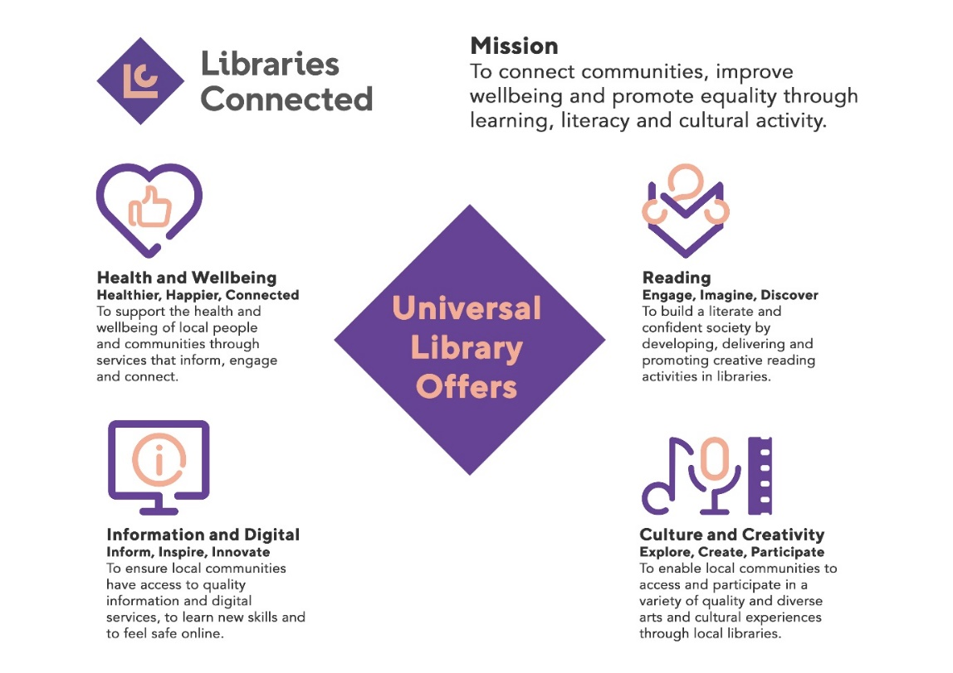

Our Vision, Purpose and Values Our Vision
Here at Lancashire County Council we are helping you to make Lancashire the best place to live, work, visit and prosper as well as being the place where everyone acts responsibly
- The above is the vision of Lancashire County Council and forms part of the county council's planning and performance framework. Lancashire libraries contribute to the vision through the goals and objectives that will be detailed in this strategy
- Libraries will provide connections to our communities which create a sense of place and help to celebrate Lancashire as a great county in which to live and work
The goals and objectives detailed in this strategy will help Lancashire libraries to deliver the vision of the County Council.

Lancashire libraries' vision is:
"A library service which is embedded and flourishing at the heart of Lancashire communities and community life and which makes a difference through reading, information, digital, health, learning and culture".
Libraries will become the venue of choice:
- Businesses and community groups will be encouraged to use our spaces for meetings, displays and exhibitions.
- People and families will experience high quality cultural and theatrical events and be able to come together as communities to learn about and celebrate our county’s heritage.

Our Purpose
Enriching lives in Lancashire
- Libraries enrich people's lives across Lancashire on a daily basis by providing a vibrant and modern library service.
- We have a positive impact on people's lives, through the information we provide and the experiences we offer both virtually and face to face.
- Our purpose is to offer information, inspiration, and connectedness and to strive to create opportunities for all.
Lancashire libraries aim to provide access for everyone to quality resources, knowledgeable and customer-focused staff and a welcoming library space.

Our Values
Supportive | Innovative | Respectful | Collaborative
We will support our customers and colleagues, recognising their contributions and making the best of their strengths to enable our communities to flourish. | We will deliver the best services we possibly can. We are always looking for creative ways to do things better, putting the customer at the heart of our thinking and being ambitious and focused on how we can deliver the best services now and in the future. | We will treat colleagues, customers and partners with respect, listening to their views, empathising with them and valuing their diverse needs and perspectives. We aim to be fair, open, and honest in all that we do | We will listen to, engage with, learn from and work with colleagues, partners, and customers to help achieve the best outcomes for everyone.

Strategic Priorities - our goals
Lancashire libraries have identified four strategic priorities which will help to meet the County Council's vision of enriching lives in Lancashire.
- Offering a community-focused library service, which is well resourced, accountable, and creative for everyone now and in the future.
- Libraries first: ensuring that libraries are at the heart of delivering county council and community services, actively collaborating with partners for mutual benefit.
- Resilient communities: use libraries to ensure that customers are healthier and have a better quality of life.
- Innovative and sustainable libraries which are flexible and adaptable to respond quickly to changing circumstances.
Customer interactions and requirements of the library service are likely to continue during the period of this strategy so it is important that it provides the flexibility and ability to allow Lancashire libraries to respond appropriately to differing needs and opportunities.

Strategic Priority 1 - Offering a community-focused library service, which is well resourced, accountable, and creative for everyone now and in the future
Corporate priorities: Delivering better services; Supporting economic growth; Caring for the vulnerable

We will aim to raise awareness of library services and their benefits to ensure wider community engagement.
We will be ambitious and committed to improving the quality of our library service.
We will be inclusive and reflect the diversity of the local communities.
We will a provide a high-quality library service, making good use of the Libraries Connected proposed accreditation scheme which will support service development and meet the needs of local communities.
By raising awareness and expanding the range of library services on offer we will increase the number of local people who benefit from the skills, resources and opportunities available in libraries to improve their quality of life and fulfil their potential through participation, creativity and learning.

Strategic Priority 2 - Libraries first: ensuring that libraries are at the heart of delivering county council and community services, actively collaborating with partners for mutual benefit
Corporate priorities: Supporting economic growth; Caring for the vulnerable

The National Libraries Taskforce has identified an ambition for council services and community partners to understand what libraries have to offer them and see them as their first choice to provide information, signposting, and services within local communities.
By demonstrating what libraries can offer to the county council and community partners we will increase opportunities for libraries to play a more central role delivering council services to communities across the county and nationally
We will make significant steps on our journey to be the partner of choice. The neutrality of our library services engenders trust in people and we are uniquely positioned in terms of customer engagement within our communities
We will put libraries at the heart of delivering council and community services

Strategic Priority 3 - Resilient communities: use libraries to ensure that customers are healthier and have a better quality of life
Corporate priorities: Supporting economic growth; Caring for the vulnerable
We will continue to create digital opportunities for all.
We will use our libraries to deliver a service that ensures customers are healthier, have a better quality of life and are resilient and well connected.
We will work with our learning partners to offer a wide range of courses which will support the citizens of Lancashire to obtain employment and provide them with the skills to grow and flourish in the workplace.

Strategic Priority 4 - Innovative and sustainable libraries which are flexible and adaptable to respond quickly to changing circumstances.
Corporate priorities: Protecting our environment; Supporting economic growth
We will be adaptable and innovative to future-proof our libraries. We will keep up to date with national and local trends as well as maintaining a good understanding of our local communities,
Lancashire libraries will be environmentally responsible and innovative in our approach to the climate emergency. Arts Council England recognises that cultural organisations lead the way in their approach to environmental responsibility and states "The climate crisis and environmental degradation will be the most significant challenge facing all of us over the next decade and beyond"
We will ensure that our workforce have the right blend of skills, competencies, attitudes, and behaviours to face the future with confidence. We will attract, retain, and develop talent from diverse backgrounds by providing opportunities which encourage young people into the workplace.

How we will measure our performance
We have established different ways of measuring our performance. Each year we will:
- Produce an operational plan and ensure that this strategy is delivered. We will create and review annual plans within the framework of this strategy. This will ensure that we deliver a service which is relevant to the individuals and communities of Lancashire.
- Produce an annual report.
- Measure against key performance Indicators for all areas of our strategy and which will be regularly reviewed.
- Benchmark performance against other local authorities.
- Monitor our services by using both data and the experiences of our communities.
- Monitor our financial budget.
- Review progress and make any additional actions needed to implement the strategy.

Background papers
This strategy has been informed by and supports the message and ambitions of the following key documents:
- The Department for Culture, Media and Sports (DCMS): Libraries Deliver: Ambition for Public Libraries in England in 2016-2021
- The Chartered Institute of Library and Information Professionals (CILIP): Public Library Skills Strategy 2017-2030
- A revised strategy for Lancashire's libraries 2017-21, LCC 2017
- DCMS strategic toolkit (https://www.gov.uk/government/publications/longer-term-evidence-based-sustainable-planning-toolkit/longer-term-evidence-based-sustainable-planning-toolkit
- Public Library Service Accreditation: consultation and scoping. Libraries Connected, November 2020
- Our Vision for Lancashire, Lancashire County Council, 2019
- Let's create: Our Strategy 2020 – 2030, Arts Council England, 2020
- Our strategy for Libraries, Museums, Culture and Archives 2019 – 2024, LCC 2019
- Equality Objectives , Lancashire County Council, April 2020

